CPE301 – SPRING 2019

Design Assignment 1A

Student Name: Carlos D Zuniga

Student #: 2000783713

Student Email: zunigc2@unlv.nevada.edu

Primary Github address: https://github.com/cdaniel64/blassen

Directory: [Design Assignments/DA1/DA1A/CPE301 Design 1A](https://github.com/cdaniel64/blassen/tree/master/Design%20Assignments/DA1/DA1A/CPE301%20Design%201A)

1. **Perform a multiplication of a 16-bit multiplicand with an 8-bit multiplier without using the MUL instruction. Use iterative addition to perform the above multiplication:**

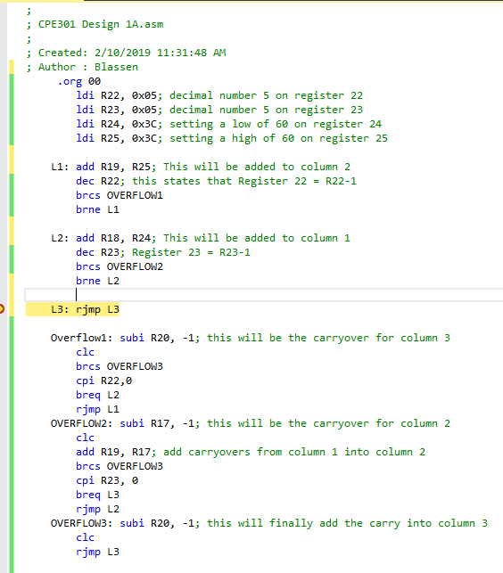

1. **Registers R25:R24 hold the 16-bit multiplicand, R22 hold 8-bit multiplier, and R20:R19:R18 should hold the result**

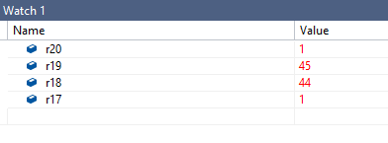

1. **Verify your algorithm and answers using the AVR mul instruction or C or any high-level program**

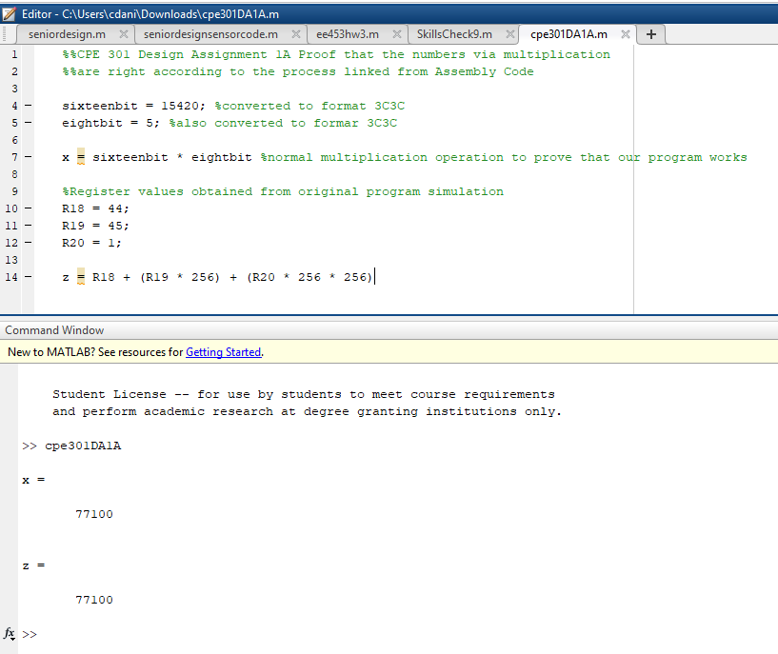

1. **Determine the execution time @ 16MHz/#cycles of your algorithm using the simulation.**

